**实验　空气热机**

**专业­­___________________学号­___________________姓名­___________________**

一、预习要点

1. 掌握热机原理及循环过程；在写预习报告的原理部分时，要结合视频讲解与教材及网上自行查找的资料，抓住重点：（1）写出空气热机（斯特林热机）的热循环原理（或画图解释）；（2）至少列举出一个除[卡诺循环](http://zh.wikipedia.org/wiki/%E5%8D%A1%E8%AF%BA%E5%BE%AA%E7%8E%AF)外，其它类型热机的热力学循环过程；
2. 认真观看视频中对于三台仪器功能的介绍，熟悉实验操作流程；熟悉不同实验内容的线路连接与热源功率及力矩计的调节；

装订处

1. 记录实验数据时需要画图，**请备好铅笔、直尺和橡皮**；
2. **在课前写好预习报告，上课时务必将预习报告和原始数据表格一并带来，否则扣分**。

二、实验注意事项

1. 热机汽缸等部位为玻璃制造，容易损坏，请谨慎操作。
2. 加热端在工作时及停止加热后1小时内均处于高温状态，请小心操作，以免烫伤。
3. 热机在没有运转的状态下，严禁长时间大功率加热；若热机运转过程中因各种原因停止转动，必须用手拨动飞轮帮助其重新运转或停止加热，否则会损坏仪器。
4. 当热机转速超过15 n/s（会伴随发出间断蜂鸣声），此时应立刻停止飞轮运转，将电加热器电源输出断开（调低），停止加热。
5. 飞轮在运转时，应谨慎操作，避免被飞轮边沿割伤。
6. 记录测量数据前须保证已基本达到热平衡，避免出现较大误差。等待热机稳定读数的时间一般在5~10分钟左右。
7. 在读取仪表上所显示的数据时，数字有跳跃现象，可能出现读数上的偏差，除采用多次测量减小误差外，同组人之间应分工合理，眼明手快。
8. 在读力矩的时候，力矩计可能会摇摆，这时可以用手轻托力矩计底部，缓慢放手后可以稳定力矩计；如还有轻微摇摆，读取中间值。
9. 根据示波器所显示的*P*-*V*图估计其面积时，一定要合理堆砌，仔细斟酌，减小偏差。

三、数据处理要求

1. 以Δ*T*/ *T*1为横坐标，*nA*/Δ*T*为纵坐标，在坐标纸上作出*nA*/Δ*T*与Δ*T*/ *T*1的关系图，以此来验证卡诺定理。
2. 以*n*为横坐标，*P*0为纵坐标，在坐标纸上作*P*0与*n*的关系图，表示同一输入功率下，输出偶合不同时输出功率或效率随偶合的变化关系。

四、思考题（**注意要抄题目后再回答对应的问题**）

1. 分析说明热机效率损失的原因有哪些?
2. 为什么*P*-*V*图的面积即等于热机在一次循环过程中将热能转换为机械能的数值?
3. 根据所做的*nA*/Δ*T*与Δ*T*/ *T*1热功转换关系图，说明在外加负载不变的情况下，随加热功率增大，*nA*/Δ*T*与Δ*T*/ *T*1基本具有________关系，验证了卡诺定理。
4. 根据所做*P*0与*n*的关系图，说明在同一加热功率下，随摩擦力矩加大，热端温度________，温度差________，转速________。输出效率先是随摩擦力矩的加大而增加，但由于转速下降较多，导致输出效率下降。（填“升高”或“降低”）
5. 分析实验过程中的误差有哪些，该怎样消除？（最少列举出四个）

五、原始数据记录表格

**成绩­­**__________ **教师签字­­**_______________**组号­­**________ **同组人姓名­­**____________________

装订处

**表1 热功转换*nA*/Δ*T*与Δ*T*/ *T*1的关系值**

|  |  |  |  |  |  |  |
| --- | --- | --- | --- | --- | --- | --- |
| **加热电压*V*** | **热端温度**  **平均值*T*1** | **温度差**  **平均值Δ*T*** | **Δ*T*/ *T*1** | ***A*（*p*-*V***  **图面积）** | **热机转速**  **平均值*n*** | ***nA*/Δ*T*** |
|  |  |  |  |  |  |  |
|  |  |  |  |  |  |  |
|  |  |  |  |  |  |  |
|  |  |  |  |  |  |  |
|  |  |  |  |  |  |  |

**实验*P*-*V*图**

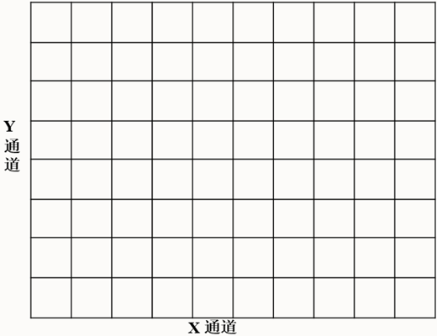 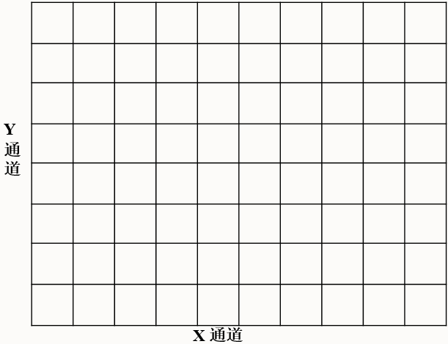

**对应的加热电压为_______________ 对应的加热电压为_______________**

**表2 测量热机输出功率随负载及转速的变化关系**

|  |  |  |  |  |  |  |
| --- | --- | --- | --- | --- | --- | --- |
| **输出力矩*M*** | **热端温度**  **平均值*T*1** | **温度差**  **平均值Δ*T*** | **热机转速**  **平均值*n*** | **输出功率**  ***P*o=2π*nM*** | **输入功率**  ***P*i=*VI*** | **输出效率**  ***η*o/i=*P*o/*P*i** |
|  |  |  |  |  |  |  |
|  |  |  |  |  |  |
|  |  |  |  |  |  |
|  |  |  |  |  |  |
|  |  |  |  |  |  |

**教师签字­­**_______________**组号­­**________ **同组人姓名­­**___________________

装订处

**附表1 测量不同加热电压下的各参数**

1. **加热电压*V*=__________**

|  |  |  |  |  |  |  |  |  |  |  |
| --- | --- | --- | --- | --- | --- | --- | --- | --- | --- | --- |
| 测量次数 | 1 | 2 | 3 | 4 | 5 | 6 | 7 | 8 | 9 | 10 |
| 热端温度*T*1 |  |  |  |  |  |  |  |  |  |  |
| 温度差Δ*T* |  |  |  |  |  |  |  |  |  |  |
| 热机转速*n* |  |  |  |  |  |  |  |  |  |  |

1. **加热电压*V*=__________**

|  |  |  |  |  |  |  |  |  |  |  |
| --- | --- | --- | --- | --- | --- | --- | --- | --- | --- | --- |
| 测量次数 | 1 | 2 | 3 | 4 | 5 | 6 | 7 | 8 | 9 | 10 |
| 热端温度*T*1 |  |  |  |  |  |  |  |  |  |  |
| 温度差Δ*T* |  |  |  |  |  |  |  |  |  |  |
| 热机转速*n* |  |  |  |  |  |  |  |  |  |  |

1. **加热电压*V*=__________**

|  |  |  |  |  |  |  |  |  |  |  |
| --- | --- | --- | --- | --- | --- | --- | --- | --- | --- | --- |
| 测量次数 | 1 | 2 | 3 | 4 | 5 | 6 | 7 | 8 | 9 | 10 |
| 热端温度*T*1 |  |  |  |  |  |  |  |  |  |  |
| 温度差Δ*T* |  |  |  |  |  |  |  |  |  |  |
| 热机转速*n* |  |  |  |  |  |  |  |  |  |  |

1. **加热电压*V*=__________**

|  |  |  |  |  |  |  |  |  |  |  |
| --- | --- | --- | --- | --- | --- | --- | --- | --- | --- | --- |
| 测量次数 | 1 | 2 | 3 | 4 | 5 | 6 | 7 | 8 | 9 | 10 |
| 热端温度*T*1 |  |  |  |  |  |  |  |  |  |  |
| 温度差Δ*T* |  |  |  |  |  |  |  |  |  |  |
| 热机转速*n* |  |  |  |  |  |  |  |  |  |  |

1. **加热电压*V*=__________**

|  |  |  |  |  |  |  |  |  |  |  |
| --- | --- | --- | --- | --- | --- | --- | --- | --- | --- | --- |
| 测量次数 | 1 | 2 | 3 | 4 | 5 | 6 | 7 | 8 | 9 | 10 |
| 热端温度*T*1 |  |  |  |  |  |  |  |  |  |  |
| 温度差Δ*T* |  |  |  |  |  |  |  |  |  |  |
| 热机转速*n* |  |  |  |  |  |  |  |  |  |  |

**附表2 测量不同输出力矩下的各参数**

装订处

1. **输出力矩*M* =__________**

|  |  |  |  |  |  |  |  |  |  |  |
| --- | --- | --- | --- | --- | --- | --- | --- | --- | --- | --- |
| 测量次数 | 1 | 2 | 3 | 4 | 5 | 6 | 7 | 8 | 9 | 10 |
| 热端温度*T*1 |  |  |  |  |  |  |  |  |  |  |
| 温度差Δ*T* |  |  |  |  |  |  |  |  |  |  |
| 热机转速*n* |  |  |  |  |  |  |  |  |  |  |

1. **输出力矩*M* =__________**

|  |  |  |  |  |  |  |  |  |  |  |
| --- | --- | --- | --- | --- | --- | --- | --- | --- | --- | --- |
| 测量次数 | 1 | 2 | 3 | 4 | 5 | 6 | 7 | 8 | 9 | 10 |
| 热端温度*T*1 |  |  |  |  |  |  |  |  |  |  |
| 温度差Δ*T* |  |  |  |  |  |  |  |  |  |  |
| 热机转速*n* |  |  |  |  |  |  |  |  |  |  |

1. **输出力矩*M* =__________**

|  |  |  |  |  |  |  |  |  |  |  |
| --- | --- | --- | --- | --- | --- | --- | --- | --- | --- | --- |
| 测量次数 | 1 | 2 | 3 | 4 | 5 | 6 | 7 | 8 | 9 | 10 |
| 热端温度*T*1 |  |  |  |  |  |  |  |  |  |  |
| 温度差Δ*T* |  |  |  |  |  |  |  |  |  |  |
| 热机转速*n* |  |  |  |  |  |  |  |  |  |  |

1. **输出力矩*M* =__________**

|  |  |  |  |  |  |  |  |  |  |  |
| --- | --- | --- | --- | --- | --- | --- | --- | --- | --- | --- |
| 测量次数 | 1 | 2 | 3 | 4 | 5 | 6 | 7 | 8 | 9 | 10 |
| 热端温度*T*1 |  |  |  |  |  |  |  |  |  |  |
| 温度差Δ*T* |  |  |  |  |  |  |  |  |  |  |
| 热机转速*n* |  |  |  |  |  |  |  |  |  |  |

1. **输出力矩*M* =__________**

|  |  |  |  |  |  |  |  |  |  |  |
| --- | --- | --- | --- | --- | --- | --- | --- | --- | --- | --- |
| 测量次数 | 1 | 2 | 3 | 4 | 5 | 6 | 7 | 8 | 9 | 10 |
| 热端温度*T*1 |  |  |  |  |  |  |  |  |  |  |
| 温度差Δ*T* |  |  |  |  |  |  |  |  |  |  |
| 热机转速*n* |  |  |  |  |  |  |  |  |  |  |